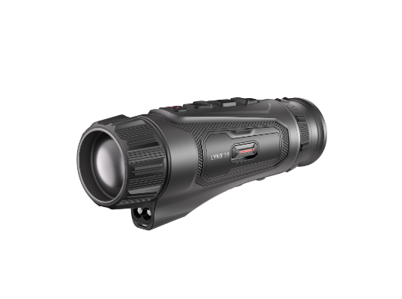
LQ35L 3.0
Thermal Monocular

With a basic magnification of 1.9x, a 640x512 detector, and a 35mm F1.0 lens, a 1000m LRF，the LQ35L 3.0 offers unparalleled performance for professional hunters and mid-to-long-range applications. Its 7.5° (13.1m at 100m) field of view and a detection range of up to 1800m ensure exceptional detail in vast, open spaces, making it the ultimate choice for users seeking premium quality with proven shutterless technology.

- Key Feature
- Up to 640×512 Thermal resolution
- High-sensitivity thermal module with NETD ＜ 15 mK (@25°C, F# = 1.0).
- 35 mm, F1.0 lens with thermal detection range up to 1800 m
- HIKMICRO Shutterless Imaging System (HSIS)
- AI-powered Image Pro 3.0 and Zoom Pro algorithms
- 0.49-inch OLED display with 1920 × 1080 resolution
- Up to 1000m Laser Range finder
- Replaceable and rechargeable 18650 battery provides up to 4.5 hours of continuous operation at -20°C

- Specification
Thermal Module
Image Sensor | VOx Uncooled Focal Plane Arrays
Max. Resolution | 640x512
Frame Rate | 50Hz
Pixel Interval | 12μm
Response Waveband | 8μm to 14μm
NETD | Less than 15 mK (@25°C),F#=1.0
Lens (Focal Length) | 35mm, f1.0
Focus Mode | Focus Ring
Detection Range | 1800m
Min. Focusing Distance | 3.5m
Magnification | 1.9x - 15.2x (8x)
Field of View(H × V), Degrees / m @100m | 12.5°×7.5°/21.9m×13.2m
Image Display
Display | 1920x1080, 0.49 inch, AMOLED
Palettes | Black Hot, White Hot, Red Hot, Fusion, Red Monochrome, Green Monochrome
Exit Pupil | 6mm
Eye Relief | 20mm
Diopter (Range) | -5D to +3D
Brightness Adjustment | Yes
Tone Adjustment | Cold, Warm
Contrast Adjustment | Yes
Zoom Pro | Yes
HSIS (HIKMICRO Shutterless Image System) | Yes
Image Pro 3.0 | Yes
System
Record Video | Yes
Capture Snapshot | Yes
Audio Recording | Yes
Standby Mode | Yes
Built-in Memory | Built-in EMMC (64 GB)
PIP | Yes
Hotspot | 2.4 GHz/5 GHz Wi-Fi Waveband
Hot Track | Yes
Distance Measurement | Yes
Local Album | Yes
Power Supply
Battery Type | Replaceable and Rechargeable Li-ion 18650 Battery
Battery Operating Time | 5-hour continuous running with hotspot on (@25°C)  4.5-hour continuous running with hotspot on (@-20°C)
Type-C Power Supply | 5V DC, 2A  Supports External Power Supply, Support Direct Charging
General
Protection Level | IP67
Dimension | 173.3 x 66.8 x 49.3 mm
Weight | 410.7g with battery
Working Temperature | From -30°C to 45°C (-22°F to 113°F);  Humidity: 90% or Less
Laser Rangefinder
Safety Class for Laser | Class 1
Wavelength | 905nm
Max. Measuring Range | 1200m
Measurement Accuracy | ±1m
Min. Measuring Range | 5m

- Available Model
HM-TSF6-35Y1G/W1L-LQ35L 3.0
- Dimension
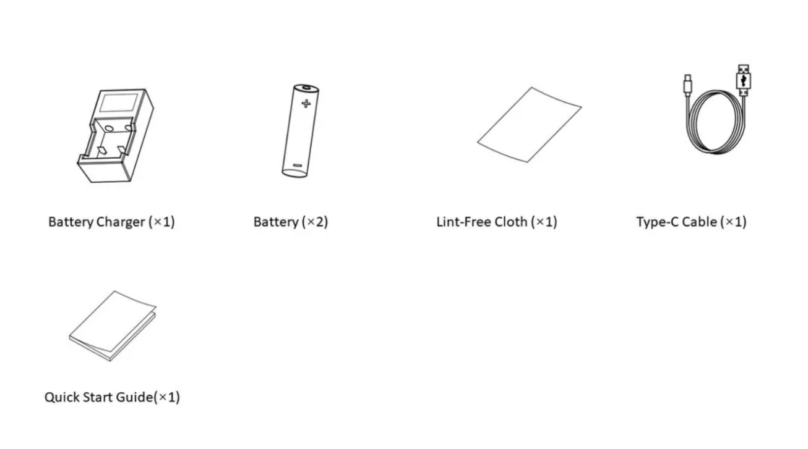
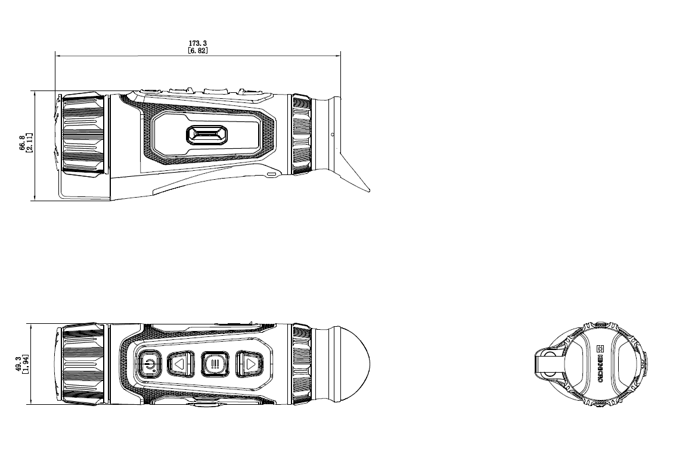

- Accessory
- Included
HM-3632DC
Battery
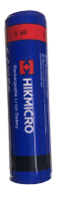
- Optional
HM-OUTDOOR-POUCH  Monocular Pouch | HM-RMB-LF  HM-RMB-LF
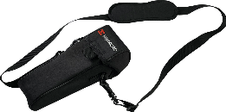 | 